

# RESEARCH ETHICS BOARDS

# APPLICATION FORM

**Prospective Research**

This form should only be used if new data will be collected. For research involving only secondary use of existing information (such as health records, student records, survey data or biological materials), use the *REB Application Form – Secondary Use of Information for Research.*

This form should be completed using the [*Guidance for Submitting an Application for Research Ethics Review*](https://cdn.dal.ca/content/dam/dalhousie/pdf/research-services/REB/Dal%20REB%20Application%20Instructions%20-%20Prospective%20Research%20%20v2021-02.pdf).

## SECTION 1. ADMINISTRATIVE INFORMATION [File No: 2022-6028 office only]

|  |
| --- |
| Indicate the preferred Research Ethics Board to review this research:  [ ] Health Sciences OR [X] Social Sciences and Humanities |

|  |
| --- |
| **Project Title:** Visualizing Uncertainty with Chromatic Aberration |

|  |  |  |  |  |  |  |  |
| --- | --- | --- | --- | --- | --- | --- | --- |
| **1.1** **Research team information** | | | | | | | |
| Lead researcher  (at Dalhousie) | Name | Md Rashidul Islam | | | | | |
| Email (@dal) | md313724@dal.ca | | Phone | | | 902-448-3533 |
| Banner # | B00870359 | | Academic Unit | | | Comp Sci |
| Co-investigator names, affiliations, and email addresses | Dr. Stephen Brooks, sbrooks@cs.dal.ca | | | | | | |
| Contact person for this submission (if not lead researcher) | Name |  | | | | | |
| Email |  | | | Phone |  | |
| Study start date | March 12, 2022 | | Study end date | | March 25, 2022 | | |

|  |  |  |  |
| --- | --- | --- | --- |
| **1.2** **For student submissions** (including medical residents and postdoctoral fellows) | | | |
| Degree program | Master of Computer Science | | |
| Supervisor name and department | Dr. Stephen Brooks | | |
| Supervisor Email (@dal) | sbrooks@cs.dal.ca | Phone | 902-494-2512 |
| Department/unit ethics review (if applicable). **Undergraduate minimal risk research only**. | | | |
| Attestation: [ ] I am responsible for the unit-level research ethics review of this project and it has been approved.  Authorizing name:  Date: | | | |

|  |  |  |  |  |
| --- | --- | --- | --- | --- |
| **1.3** **Other reviews** | | | | |
| Other ethics review (if any) for this research | | Where? |  | |
| Status? |  | |
| Scholarly/scientific peer review (if any) |  | | | |
| Is this a variation on, or extension of, a previously approved Dal REB submission? | | | | [X] No  [ ] Yes Dal REB file #________________ |
| **If yes**, describe which components of the current submission are the same as the previously approved submission (list section numbers), and which components are different from the previously approved submission (list section numbers). You may also use highlighting to clearly indicate revised text. | | | | |

|  |  |  |
| --- | --- | --- |
| **1.4** **Funding**  [x] Not Applicable | | |
| Funding (list on consent form) | Agency |  |
| Award Number |  |
| Institution where funds are/will be held | [ ] Dalhousie University  [ ] Other: _____________________ |
| Was a Dal release of funds agreement issued for this award? | | [ ] Yes Date of RoF Agreement: ____________ |

|  |
| --- |
| **1.5 Attestation(s).** The appropriate boxes *must* be checked for the submission to be accepted by the REB |
| **[X]** I am the **lead researcher** (at Dalhousie) named in section 1.1. I agree to conduct this research following the principles of the Tri-Council Policy Statement *Ethical Conduct for Research Involving Humans* ([TCPS](http://www.pre.ethics.gc.ca/eng/policy-politique_tcps2-eptc2_2018.html)) and consistent with the University [*Policy on the Ethical Conduct of Research Involving Humans*](http://www.dal.ca/dept/university_secretariat/policies/human-rights---equity/ethical-conduct-of-research-involving-humans-policy.html).  I have completed the TCPS Course on Research Ethics ([CORE](http://tcps2core.ca/welcome)) online tutorial.  [X] Yes [ ] No  For Supervisors (of student / learner research projects):  **[X]** I am the **supervisor** named in section 1.2. I have reviewed this submission, including the scholarly merit of the research, and believe it is sound and appropriate. I take responsibility for ensuring this research is conducted following the principles of the [TCPS](http://www.pre.ethics.gc.ca/eng/policy-politique_tcps2-eptc2_2018.html) and University [Policy](http://www.dal.ca/dept/university_secretariat/policies/human-rights---equity/ethical-conduct-of-research-involving-humans-policy.html).  I have completed the TCPS Course on Research Ethics ([CORE](http://tcps2core.ca/welcome)) online tutorial.  [X] Yes [ ] No |

## SECTION 2. PROJECT DESCRIPTION

|  |
| --- |
| **2.1 Lay summary** |
| 2.1.1 In **plain language**, describe the rationale, purpose, study population and methods to be used. Include a summary of background information or literature to contextualize the study. What new knowledge, or public or scientific benefit is anticipated? [maximum 500 words]  Visualization is a way of representing digital information to the user as a shape or collection of shapes/charts such as circle, rectangle, table, grid, etc. One of the most popular approaches of such visualization is drawing charts to show in computer screen. Due to the nature of uncertainty in digital information, when they are used to draw charts, some amount of distortion, deviation, and inconsistency may appear on their shapes than that of expected. We have introduced a new technique to visualize such information uncertainties in computer display called Chromatic Aberration (CA).  Technology has been evolved and enhanced greatly in the recent years. With the help of this technological improvement people can forecast or estimate future events or trend such as weather prediction, market price or sales, traffic congestion estimation, disease outbreaks or epidemics etc. All these predictions are done by computer software by employing special formulae. Many such formulas have been created by computer scientist and utilized to forecast the cruellest pandemic COVID-19. We have used four of those formulas to generate predictive data and which is eventually used in our research to draw the chart to visualize those uncertainties.  We have designed the study by categorizing the prediction data error into several levels because the purpose of this study is the investigate whether our new technique can be used successfully to represent uncertainty in terms of CA and determine how accurately viewers can detect those levels of errors in the chart. The similar procedure of user perception justification will be applied with an existing approach called VSUP [Correll et al., 2018]. The whole process will be conducted interactively with users through our online website.  We have created smaller units of chart with a bubble/rectangle for each country that contains three overlapping circles/rectangles of three different colours namely Red (R), Green(G), and Blue(B). The centre of the overlapping circles/rectangles is shifted from each other around by the amount of data error and the size of the circle is determined by the number of new cases for that country. So, the resultant circle/bubble would have outer edge non-overlapped and hence that edge will be filled with one of R, G, B colours and fully overlapped part will be filled with combination of R, G, B color. The thickness of that outer edge proportional to the amount of error. The prime concern of the study is to detect how perfectly the participants could perceive the level of thickness of edges.  The anticipated new knowledge will potentially be a novel method of data visualization, for instance, it may be applicable to a wide variety of data domains. The aim will be to produce a journal paper that will report the suitability of chromatic aberration for this purpose. In addition, it can be used in real life charts to denote the errors of data. For example: if we draw a country-wise bubble chart on world map, then it gives clear insight in one go about which countries have higher amount of error.  [ ] This is a pilot study.  [X ] This is a fully developed study. |
| 2.1.2 Phased review. If a phased review is being requested, describe why this is appropriate for this study, and which phase(s) are included for approval in this application. Refer to the [guidance document](https://cdn.dal.ca/content/dam/dalhousie/pdf/research-services/REB/Dal%20REB%20Application%20Instructions%20-%20Prospective%20Research%20%20v2021-02.pdf) before requesting a phased review.  [x] Not applicable |

|  |
| --- |
| **2.2** **Research question** |
| State the research question(s) or research objective(s).  The focus of the research is to calculate uncertainty from the forecasted results of machine learning predictive models and then represent these uncertainties in visualization in terms of chromatic aberration. In particular, we will conduct a comparative evaluation of visual uncertainty representations: our proposed chromatic aberration method and Value-Suppressing Uncertainty Palettes (VSUP) [Correll et al., 2018]. |

|  |
| --- |
| **2.3** **Recruitment** |
| 2.3.1 Identify the study population. Describe and justify any inclusion / exclusion criteria. Also describe how many participants are needed and how this was determined.  The population for our study will include members of the Dalhousie University community but may extend beyond to other universities and to the general public. We also require participants to be fluent in English because there will be questionnaires and interviews.  One of the prime criterions for the selection process is to test for color-blindness of the participants. The participants must be capable to decern color in order to provide meaningful data for the study. As in Correll et al. [2018] we will “present participants with a set of Ishihara plates [Hardy 1945], and exclude those that misidentified values or who self-reported as having a color vision deficiency”. See Appendix F.  The study population will be at least post-secondary students or professionals who have some degree of computer experience as a user of common computer applications. In particular, they must have some knowledge of how to use the internet because the study will be conducted online. The study program will be deployed on a server and participants need to make sure they have internet connection with their computer or laptop, and they can access and use it through the freely available Firefox browser.  We aim to recruit 32 participants. We have four sections in the survey including one component of a published paper. Each component has 8 questions. We have used [counter balancing](▪%09https:/www.yorku.ca/mack/RN-Counterbalancing.html) among four sections as well as 8 questions of each section. That means order of the sections are in balanced-latin-square method and questions will come up randomly. To ensure equal priority of the components and to make the study fair, we decided to select (4x8=32) participants. |
| 2.3.2 Describe recruitment plans and append recruitment instruments. Describe who will be doing the recruitment and what actions they will take, including any screening procedures.  Recruitment will be conducted by the primary researcher under the supervision of the supervisor. Due to COVID restrictions imposed by the provincial authority and for the sake of respecting health priority of Dal community, we decided to contact with the participants through email and digital messaging boards. Participants will initially be recruited through Dalhousie’s digital message boards, including Notice Digest (notice.digest@dal.ca), the Computer Science Mailing List (cs.all@dal.ca) and the Dal Students emails (dalstudent@dal.ca) and physical bulletin boards on campus. If necessary, further recruits will be sought from similar message boards at other Canadian universities as well as message boards used in the data visualization community.  When potential participants respond to the recruitment notice, we will email them the inclusion criteria (English fluency, some experience with computers, full color vision) to assure that they meet the inclusion criteria. The screening email is given in Appendix B. |
| 2.3.3 If you require permission, cooperation, or participation from a community, organization or company to recruit your participants, describe the agreement obtained from the relevant group(s). Attach correspondence indicating their cooperation and/or support (required). Describe any other community consent or support needed to conduct this research. (If the research involves Indigenous communities complete section 2.11).  [x] Not applicable |

|  |
| --- |
| **2.4** **Informed consent process** |
| 2.4.1 Describe the informed consent process:  A) How, when and by whom will the study information be conveyed to prospective participants? How will the researcher ensure prospective participants are fully informed?  Prospective participants will receive a copy of the consent letter (Appendix A) and second email (Appendix C) after they indicated an interest in participating in the study by going through “Initial Email or Poster in Bulletin Board on Campus” (Appendix B). They will be instructed to read the consent letter before giving their consent. The email will also indicate to prospective participants that they can ask clarifying questions regarding the study.  B) Describe how consent will be documented (e.g. written signature, audio-recorded, etc.).  Consent will be recorded by considering the willingness through email after going through the consent letter and second email with details.  Participants who opt not to provide consent and not to participate will not be able to participate in the survey later.  [ X ] Append copies of all consent information that will be used (e.g. written consent document, oral consent script, assent document/script, etc.).  Note: If the research will involve third party consent (with or without participant assent), and/or ongoing consent, ensure these are described above. |
| 2.4.2 Discuss how participants will be given the opportunity to withdraw their participation (and/or their data) and any time (or content) limitations on this. If participants will not have opportunity to withdraw their participation and/or their data explain why.  Participants are informed in the consent form and that they can withdraw from the study at any time.  Participants can opt to withdraw their data from the study up to 1 week after the interview because after that we will use the data in de-identified form (with numerical analysis) for our report. If a participant opts to withdraw in time from the study, their questionnaire, survey response, all recorded audio and video (screenshare only) will also be deleted permanently. |
| 2.4.3 If an alteration/exception to the requirement to seek prior informed consent is sought, address the criteria in TCPS article [3.7A](http://www.pre.ethics.gc.ca/eng/tcps2-eptc2_2018_chapter3-chapitre3.html#b). If the alteration involves deception or nondisclosure, also complete section 2.4.4.  [X] Not applicable |
| 2.4.4 Describe and justify any use of deception or nondisclosure and explain how participants will be debriefed.  [X] Not applicable |

|  |
| --- |
| **2.5** **Methods, data collection and analysis** |
| 2.5.1  A) Where will the research be conducted?  Research will be conducted remotely using Microsoft Teams or Skype based on the participant’s convenience. So, the participants will be able to participate in the study from their homes.  B) What will participants be asked to do?  We have developed a web application and for this reason participants do not need to install any specialized software in his/her own machine for this study other than a browser (Firefox) and a communicating medium (software), for example: Skype. We will provide a URL and then participants will be asked to navigate to the application. From there they will directly access the visualizations.  They will be asked to share their screen using Skype or MS Teams to show the running application. They will then be given short interactive tasks that will give them instruction on how to interact with the methods of visually representing uncertainty. The same tasks will be done when evaluating the competing uncertainty visualization approaches. Images of the screenshots are given in Appendix D along with the Questionnaire and examples of our implementations in different kind of charts. Each section of the questionnaire will therefore be proceeded by a short explanation session. The participants need to observe and understand the features to answer questions correctly, and we will brief them to understand the contents whenever needed.  More specifically, the general study design will have four sections of accuracy comparison between Chromatic Aberration (CA) with prior work VSUP and named them as:   * CA + Bubble * VSUP + Bubble * CA + Grid * VSUP + Grid   C) What data will be collected using what research instruments? (Note that privacy and confidentiality of data will be covered in section 2.6)  The following data will be collected:   * Answers to the questionnaire questions (Appendix D) will be collected online using our self-developed web application. So, user will go through the questionnaire through browser and answer the question and our system will automatically track the response and save as JSON in file system with their email address. * Video (screenshare only) and audio recording of screenshare session will be collected using Microsoft Teams or Skype. * Timing information will also be recorded to facilitate a comparison of the time requirements of each competing visualization approach.   It will be a within subject experiment to “control for the variation in the interpersonal differences” [Correll 2018]. Moreover, we will use sequence counter balancing to counter act any learning effects within each subject.  D) How much of the participant’s time will participation in the study require?  Approximately 1 hour will be required. The participant should go through the presentation in dynamic web application for up to 30 minutes and 30 minutes is anticipated for the completion of questionnaire section which is the main component of the survey.  [X] Append copies of all research instruments (questionnaires, focus group questions, standardized measures, etc)  [ ] This is a clinical trial (physical or mental health intervention) – ensure section 2.12 is completed |
| 2.5.2 Briefly describe the data analysis plan. Indicate how the proposed data analyses address the study’s primary objectives or research questions.  There will be several aspects to data collection and analysis. First of all, we will record the audio of participants while they perform tasks; we anticipate that participants could express frustration or describe their intensions while performing the tasks. We will use this information to help interpret the log data, described next. Second, the timings of the required tasks will be recorded automatically by our system. Third, there will a color vision test and tasks related questionnaires [Appendix F] to fill out by participants. Fourth, after all the tasks are finished, they will answer a questionnaire about the experience of using our application for two selection techniques. The questions will include the System Usability Scale (SUS) [Brooks 1986] and the NASA-TLX [NASA 1986] standardized questionnaires.  The timing of finishing tasks and user estimates of values and uncertainty will be objective quantitative measures of performance; responses to rating questionnaires will give us subjective quantitative data such as the degree of user satisfaction with the interface and confidence about finishing tasks. The data will also give us information that will allow us to further refine our interface in future work.  Post-session questionnaires (Appendix D) will provide us with additional feedback, which might not be apparent in the previous data and will help us to understand the preference of a participant’s choices more comprehensively in terms of these visualization techniques. The scoring method will be straightforward where each question will carry 1 point in every section.  Participant responses will be compared and anonymized. Positive averaged scores for the approach will support the hypothesis that chromatic aberration is more useful for uncertainty visualization over alternatives. More specifically, we will use the Shapiro-Wilk normality test [Shapiro & Wilk 1965] to determine if the responses followed a normal distribution. For comparisons we will use standard t-tests.  Participants’ feedback is also requested in written form. This feedback, in addition to comments made by the user during the screenshare, will be used as suggestions for future work. |
| 2.5.3 Describe any compensation that will be given to participants and how this will be handled for participants who do not complete the study. Discuss any expenses participants are likely to incur and whether/how these will be reimbursed.  Every participant will receive compensation of $10 (Walmart/Amazon E-Gift card) from the researcher after the study. The compensation will be given even if the participant does not finish the study. The gift-card will be sent to their email and there won’t be any other expenses in the study. Since the gift-card will be provided through email, there will be automatic history in mailbox and hence no need to sign of participant payment receipt. |

|  |
| --- |
| **2.6** **Privacy and confidentiality** |
| 2.6.1  A) Describe who will have knowledge of participants’ identities.  Only the researcher will know the relationship between participant’s name and unique participant IDs.  B) Describe the level of identifiability of the study data (anonymous, anonymized, de-identified/coded, identifying) (see [TCPS Chapter 5A – types of information](http://www.pre.ethics.gc.ca/eng/tcps2-eptc2_2018_chapter5-chapitre5.html#a) for definitions).  Data from this study will be associated to participants IDs (Coded Information).  C) Specify which members of the research team (or others) will have access to participants’ data and for what purpose.  Project supervisor might have access on participants information for validation and justify their achievement with their qualification. In other words, to justify how much the educational background or knowledge level helps to answer the questionnaire properly.  D) Describe measures to ensure privacy and confidentiality of study documents and participant data during the data collection and analysis phase. [Note that plans for long term storage will be covered in 2.6.2]   * Address: handling of documents/data during data collection; transportation or transfer of documents/data; storage of documents/data (during the study). * If a key-code will be maintained, describe how it will be kept secure. * For electronic data, describe electronic data security measures, including file encryption and/or password protection [as applicable](https://cdn.dal.ca/content/dam/dalhousie/pdf/research-services/REB/Protecting%20Electronically%20Stored%20Personally%20Identifiable%20Research%20Data.pdf). * For hard copy documents, describe physical security measures (specify location).   We will use our self-developed web application for the questionnaire. The questionnaire will include multiple choice questions and identification questions based on provided parameters. No personal information will be asked from the participants other than email to send the gift-card and computer skill/profession to evaluate our study performance based on their qualification. We will store the audio and video (screenshare only) and responses in secure space assigned for the researcher in dal-space and will keep until research work is evaluated and nobody would be able to access the data other than researcher. Researcher will be responsible to keep the data strictly secret and will not share or disclose it to anyone. After evaluation, researcher will permanently erase all kinds (audio, response, screenshare video) of data relevant to participation.  [ ] This research involves personal health records (ensure section 2.13 is completed) |
| 2.6.2 Describe plans for data retention and long-term storage (i.e. how long data will be retained, in what form and where). Will the data eventually be destroyed or irreversibly anonymized? If so, what procedures will be used for this? Discuss any plans for future use of the data or materials beyond the study currently being reviewed.  Survey responses will be stored in the Dalhousie Servers (secure web-space allocated for the researcher by Dalhousie university) through our online web application automatically. Recorded audio and video from the screenshare will be stored on the same secure server of dal-space. The response data will be stored with users email address initially and after completion of study, it will be added to the report in de-identified form and researcher will destroy the physical files after successful completion of the research. Only the researcher will have access to the collected data in this study and there is no plan to use the collected data beyond the study.  [ ] This research will be deposited in a data repository (ensure section 2.14 is completed) |
| 2.6.3  Describe if/how participant confidentiality will be protected when research results are reported:  A) For quantitative results - In what form will study data be disseminated?  [ ] Only aggregate data will be presented  [X] Individual de-identified, anonymized or anonymous data will be presented  [ ] Other. If “other”, briefly describe dissemination plans with regard to identifiability of data.  [ ] Not applicable, only qualitative data will be presented  B) For qualitative results - Will identifiable data be used in research presentations/publications? If participants will be quoted, address consent for this and indicate whether quotes will be identifiable or attributed.  [ ] Not applicable, only quantitative data will be presented  Participants are given the option to allow/disallow the researchers to use quotes when disseminating results in the consent form. These quotes would be collected from the written questions in the questionnaire (Appendix D) and from the recorded audio capture during the user study. We will use participant quotes anonymously. |
| 2.6.4 Address any limits on confidentiality, such as a legal duty to report abuse or neglect of a [child](https://novascotia.ca/coms/families/changestoCFSA/Duty-to-Report.pdf) or [adult in need of protection](https://nslegislature.ca/sites/default/files/legc/statutes/adult%20protection.pdf), and how these will be handled. Ensure these are clear in the consent documents. (See the [guidance document](https://cdn.dal.ca/content/dam/dalhousie/pdf/research-services/REB/Dal%20REB%20Application%20Instructions%20-%20Prospective%20Research%20%20v2021-02.pdf) for more information on legal duties and professional codes of ethics).  [X] Not applicable |
| 2.6.5 Will any information that may reasonably be expected to identify an individual (alone or in combination with other available information) be accessible outside Canada? And/or, will you be using any electronic tool (e.g. survey company, software, data repository) to help you collect, manage, store, share, or analyze personally identifiable data that makes the data accessible from outside Canada?  [] No  [X] Yes. If yes, refer to the University [*Policy for the Protection of Personal Information from Access Outside Canada*](http://www.dal.ca/dept/university_secretariat/policies/governance/protection-of-personal-information-policy-.html), and describe how you comply with the policy (such as securing participant consent and/or securing approval from the Vice President Research and Innovation).  Explained in Consent Form, Page: 19. 5th and 6th paragraphs. |

|  |
| --- |
| **2.7 Risk and benefit analysis** |
| 2.7.1 Discuss what risks or discomforts are anticipated for participants, how likely risks are and how risks will be mitigated. Address any particular ethical vulnerability of your study population. Risks to privacy from use of identifying information should be addressed. If applicable, address third party or community risk. (If the research involves Indigenous communities also complete section 2.11)  The use of publicly available data surrounding Covid 19 may cause some degree of discomfort to some participants, given that the data is representative of a pandemic which is of concern to all.  In addition, it is possible the use of simulated chromatic aberration may cause some minor eye strain.  Beyond the above noted concerns, there are no anticipated physical, mental, economic, or social risks associated with participation beyond those associated with everyday computer use. There may be some minor discomforts for participants in that they will be using a new software application for the first time if someone didn’t have the similar experience. We do not anticipate that this will exceed the usual levels of ambiguity or confusion commonly experienced when someone uses new software for the first time. |
| 2.7.2 Identify any direct benefits of participation to participants (other than compensation), and any indirect benefits of the study (e.g. contribution to new knowledge).  Participating in the study might benefit participants in terms of knowledge which will help them to participate in paid surveys in future, or conduct and contribute their own survey if ever required. |

|  |
| --- |
| **2.8 Provision of results to participants and dissemination plans.** |
| 2.8.1 The TCPS encourages researchers to share study results with participants in appropriate formats. Describe your plans to share study results with participants and discuss the process and format.  Participants are given a chance to add their e-mail address to receive the results of this study when it has been accepted for publication. Those participants that provided their email addresses for this purpose will receive a summary of the findings after the results are published but nobody will know other participants information. |
| 2.8.2 If applicable, describe how participants will be informed of any material incidental findings – a discovery about a participant made in the course of research (screening or data collection) that is outside the objectives of the study, that has implications for participant welfare (health, psychological or social). See [TCPS Article 3.4](http://www.pre.ethics.gc.ca/eng/tcps2-eptc2_2018_chapter3-chapitre3.html) for more information.  [ X ] Not applicable |
| 2.8.3 Describe plans for dissemination of the research findings (e.g. conference presentations, journal articles, public lectures etc.).  Results from this study will be used for the lead researcher’s MCS thesis paper and possibly for publication in Computer Science journals or conferences or in final thesis defense. |

|  |
| --- |
| * 1. Research Team |
| 2.9.1 Describe the role and duties of all research team members (including students, RA’s and supervisors) in relation to the overall study.  Dr. Brooks is a faculty member (Professor) in Computer Science. He will provide guidance during the study trials and will take part in the analysis after the event since he has previous expertise on guiding students earlier on visualization related research, conducting user studies, numerical analysis of the study results, and so on.  Investigator Rashidul Islam has developed the study design under the direction of Dr. Brooks. This study is an integral part of his MCS Thesis component. Since primary researcher is new in this kind of research and user study, he needed to discuss with supervisor time to time to make sure the direction is promising. For example: during study design researcher has tried with more alternative approaches such as noise, blurriness, transparency, etc. (one after another) to compare with his novel technique of Chromatic Aberration (CA). During these phases supervisor use to listen researcher’s idea and gave his own thoughts and discuss pros and cons together. In this way, once supervisor found [Correll 2018] and he asked researcher to explore it and find if that can be used as competitor to justify his research work, eventually that was found interesting and considered it as reference material. |
| * + 1. Briefly identify any previous experience or special qualifications represented on the team relevant to the proposed study (e.g., professional or clinical expertise, research methods, experience with the study population, statistics expertise, etc.).   Dr. Brooks has previous experience in designing and executing user studies in the field of data visualization. Investigator Rashidul Islam is novice in conducting such user studies. |

|  |
| --- |
| **2.10 Conflict of interest** |
| Describe whether any dual role or conflict of interest exists for any member of the research team in relation to potential study participants (e.g. TA, fellow student, teaching or clinical relationship), and/or study sponsors, and how this will be handled.  [ X ] Not applicable |

|  |
| --- |
| 2.11 Research involving Indigenous peoples  Consult TCPS [Articles 9.1 and 9.2](http://www.pre.ethics.gc.ca/eng/tcps2-eptc2_2018_chapter9-chapitre9.html) in determining whether this section is applicable to your research.  [ X ] Not applicable – go to 2.12 |
| 2.11.1 If the proposed research is expected to involve people who are Indigenous, describe the plan for community engagement (per TCPS Articles [9.1 and 9.2](http://www.pre.ethics.gc.ca/eng/tcps2-eptc2_2018_chapter9-chapitre9.html#c)). If community engagement is not sought, explain why the research does not require it, referencing TCPS article 9.2. |
| 2.11.2 State whether ethical approval has been or will be sought from [Mi’kmaw Ethics Watch](https://www.cbu.ca/indigenous-affairs/mikmaw-ethics-watch/) and if not, why the research does not fall under their purview. If the research falls under the purview of other Indigenous ethics groups, state whether ethical approval has been or will be sought. |
| 2.11.3 Describe plans for returning results to the community and any intellectual property rights agreements negotiated with the community with regard to data ownership (see also 2.11.4 if applicable). Append applicable research agreements. |
| 2.11.4 Does this research incorporate OCAP (Ownership, Control, Access, and Possession) principles as described in TCPS [Article 9.8](https://ethics.gc.ca/eng/tcps2-eptc2_2018_chapter9-chapitre9.html#8)?  [ ] Yes. Explain how.  [ ] No. Explain why not. |

|  |
| --- |
| **2.12** **Clinical trials**  [ X ] Not applicable – go to 2.13 |
| 2.12.1 Will the proposed clinical trial be registered?  [ ] No. Explain why not.  [ ] Yes. Indicate where it was/will be registered and provide the registration number. |
| 2.12.2 If a novel intervention or treatment is being examined, describe standard treatment or intervention, to indicate a situation of clinical equipoise exists (TCPS [Chapter 11](http://www.pre.ethics.gc.ca/eng/tcps2-eptc2_2018_chapter11-chapitre11.html)). If placebo is used with a control group rather than standard treatment, please justify. |
| 2.12.3 Clearly identify the known effects of any product or device under investigation, approved uses, safety information and possible contraindications. Indicate how the proposed study use differs from approved uses.  [ ] Not applicable |
| 2.12.4 Discuss any plans for blinding/randomization. |
| 2.12.5 What plans are in place for safety monitoring and reporting of new information to participants, the REB, other team members, sponsors, and the clinical trial registry (refer to TCPS [Articles 11.6, 11.7, 11.8](http://www.pre.ethics.gc.ca/eng/tcps2-eptc2_2018_chapter11-chapitre11.html))? These should address plans for removing participants for safety reasons, and early stopping/unblinding/amendment of the trial. What risks may arise for participants through early trial closure, and how will these be addressed? Are there any options for continued access to interventions shown to be beneficial? |

|  |
| --- |
| **2.13** **Use of personal health information**  [ X ] Not applicable – go to 2.14 |
| 2.13.1 Research using health information may be subject to Nova Scotia’s [*Personal Health Information Act*](http://novascotia.ca/dhw/phia/). Describe the personal health information ([definition explained in the guidance document](https://cdn.dal.ca/content/dam/dalhousie/pdf/research-services/REB/Dal%20REB%20Application%20Instructions%20-%20Prospective%20Research%20%20v2021-02.pdf)) required and the information sources, and explain why the research cannot reasonably be accomplished without the use of that information. Describe how the personal health information will be used, and in the most de-identified form possible. |
| 2.13.2 Will there be any linking of separate health data sets as part of this research?  [ ] No  [ ] Yes  If yes:  A) Why is the linkage necessary?  B) Describe how the linkage will be conducted (it is helpful to append a flow diagram)  C) Does that linkage increase the identifiability of the participants? |
| 2.13.3 Describe reasonably foreseeable risks to privacy due to the use of personal health information and how these will be mitigated. |

|  |
| --- |
| **2.14** **Data Repositories**  [ X ] Not applicable |
| 2.14.1 Identify and describe the data repository in which the research data will be deposited. What is its focus, who are its target users, who can access deposited data and under what circumstances? For how long will the data be kept in the repository? |
| 2.14.2 Describe the data set to be released to the repository. If there is personal and/or sensitive information in the data, describe how you will prepare the data for submission to the repository and mitigate risks to privacy. Identify all fields that will be included in the final data set (include as an appendix). |
| 2.14.3 Is agreeing to have one’s data deposited a requirement for participation in the study? If yes, provide a justification. If no, indicate how participants can opt in or out. |

## SECTION 3. APPENDICES

**Appendices Checklist.** Append all relevant material to this application in the order they will be used. This may include:

[X] Reference list

[ ] Permission or support/cooperation letters (e.g. Indigenous Band Council, School Board, Director of a long-term care facility, anyone whose permission you need to conduct recruit participants or conduct research)

[ ] Research agreements (required for research involving Indigenous communities)

[ X ] Recruitment documents (posters, oral scripts, online postings, invitations to participate, etc.)

[ ] Screening documents

[ X ] Consent/assent documents or scripts

[ X ] Research instruments (questionnaires, interview or focus group questions, etc.)

[ ] Debriefing and/or study results templates

[ ] List of data fields included in data repository

[ ] Confidentiality agreements

**Consent Form Templates**

Sample consent forms are provided on the [Research Ethics website](https://www.dal.ca/dept/research-services/responsible-conduct-/research-ethics-/resources-.html) and may be used in conjunction with the information in the [*Guidance*](https://cdn.dal.ca/content/dam/dalhousie/pdf/research-services/REB/Dal%20REB%20Application%20Instructions%20-%20Prospective%20Research%20%20v2021-02.pdf) document to help you develop your consent form.



**CONSENT FORM**

**Project title**: Visualizing Uncertainty with Chromatic Aberration

**Lead researcher**: Md Rashidul Islam, Dalhousie University, md313724@dal.ca, +1(902)4483533

**Other researchers**   
Dr. Stephen Brooks, [sbrooks@cs.dal.ca](mailto:sbrooks@cs.dal.ca)

**Funding provided by:** NIL

**Introduction**

We invite you to take part in a research study being conducted by Rashidul Islam, who is an MCS (Master of Computer Science) student at Dalhousie University. Choosing whether or not to take part in this research is entirely your choice. There will be no impact to you if you decide not to participate in the research. The information below tells you about what is involved in the research, what you will be asked to do and about any benefit, risk, inconvenience or discomfort that you might experience.   
  
You should discuss any questions you have about this study with Rashidul Islam or Dr. Stephen Brooks. Please ask as many questions as you have and we will be happy to answer your questions. If you have questions later, please contact Rashidul Islam.

**Purpose and Outline of the Research Study**Researcher has come up with a new technique of displaying uncertain information in computer screen as chart. He has created a web site that contains his new design. There are more techniques exists in the world to display such erroneous information in computer display. So, it is important to justify how effective his new technique is compared to other techniques. On this purpose, he has selected one of the closest techniques that was published in international journal. Since chart or design is usually evaluated by human eye, it needs to show a group of people, ask some specific question, and take their feedback. That’s why this is going to be conducted to find its efficacy.

**Who Can Take Part in the Research Study**Anyone can participate in this study who has basic knowledge for recognizing simple shapes such as circles, rectangles, ellipse, partial filling of circles etc. They also need to have access to a computer browser; for instance: Chrome, have good internet connection, and have a microphone connected to the computer to communicate with researcher. In addition, participants must have color vision and not be impaired by color blindness.

**What You Will Be Asked to Do**If you decide to participate in this research, you will be asked to navigate to a web application through your computer browser (Firefox). You will be asked to connect to a meeting with an audio connection and screen sharing with Skype/Teams whatever you prefer. Your audio and shared screen will be recorded for the study purpose. You will be recommended to close all other applications besides the navigated application and the communication software itself. You have to complete the survey. If you have any questions or need clarification, then researcher can explain as he will be available to you for the entire duration. The length of the session would be approximately 1 hour.

**Possible Benefits, Risks and Discomforts**

Benefits: A potential benefit could be that you will interact with new types of visualizations. Other than that, you do not have any direct benefit.

Risks: Looking at images that contain colors that are blurry may produce some eye strain. Also, the data used in the examples are country level Covid 19 statistics which may cause some concern for some participants. Beyond these noted potential minor issues, no significant risks are anticipated with this study beyond being bored or fatigued or confused by using a new piece of software just like what you may feel for using any other new software. To reduce these discomforts, we will offer you breaks between activities whenever you need.

As said, I will record your audio and screen share and will store in strictly secure space in our Dalhousie University server with a filename of your email address. So, until the study is evaluated, it will remain identifiable only by me but no one else will have access to it. At the end of the research evaluation all data will be erased by researcher with his own responsibility.

The researcher will use their Dalhousie University credentials for the Microsoft Teams meeting, which will ensure that the Teams meeting recordings are securely stored in Canada. During the live Teams meeting, audio and video content is routed through the United States, and therefore may be subject to monitoring without notice, under the provisions of the US Patriot Act while the meeting is in progress. After the meeting is complete, meeting recordings made by Dalhousie are stored in Canada and are inaccessible to US authorities.

If you prefer to use skype then we all know it is world-wide renowned secure conferencing tool, but we do not have internal knowledge about how their underlying routing goes on. So, similar to Teams meeting, skype system owners can have also hidden monitoring which is out of control to us but till data is stored, we will keep it strictly secure.

**Compensation / Reimbursement**Every participant will receive compensation of $10 (Walmart/Amazon E-Gift card) and it will be given from the researcher to the participant’s email after the study. The compensation will be given even if the participant does not finish the study.

**How your information will be protected:**Before starting the study we will inform you that your screenshare, questionnaire/answers, conversation will be recorded for future use and this information will be stored by the research team and only they will know about your participation information.

The information that we will take from you will remain highly confidential and secure. Only the research team at Dalhousie university who work with us have access to this information and all of us have an obligation to keep all these study information protected from any kind of unauthorized access. Your identity information (name and contact information) also be securely stored separately in an encoded approach. Instead of using your name or contact information, we will create a new ID number by encrypting your base information and which will be used as your participation number. In addition to that, all information will be kept secure in an encrypted file on the researcher’s password-protected computer, and we will not maintain any paper/printed documents.

Since the study is a core component of our thesis research, we will explain and share our findings in the researcher’s thesis report and thesis’s defense. We expect you allow us to use your quotes in our report if needed. But the report will not include any individual information but group results. This means that nobody will be able to identify a single participant’s information from our reports.

**If You Decide to Stop Participating**You are fully free to leave the study at any time. If you want to stop participating during the study, you can also decide whether you want to allow us to use or remove any of the information that you have given us up to that point. If you want not to keep your participation in the study after completing the study and want us to remove your data, then you can decide for up to 1 week. After that time, it will be we will remove your physical data but your response will be anonymized in analysis report and so there will be no way to trace your data individually.

**How to Obtain Results**At the end of the study, we will provide you with a short description of group results but not individual results. You can obtain these results by letting researcher know during participation.

**Questions**You are always welcome to reach out us with whatever questions or concerns you may have about your participation in this research study. Please contact at any time to Md Rashidul Islam at +1 (902) 448 3533, md313724@dal.ca or Dr. Stephen Brooks at sbrooks@dal.ca with your questions, suggestions, comments, or concerns about the research study.

If you have any ethical concerns about your participation in this research, you may also contact Research Ethics, Dalhousie University at (902) 494-3423, or email: ethics@dal.ca (and reference REB file # 20XX-XXXX).

**Signature**Signatures will not be required as part of this informed consent process. Your reply with assent will be considered as an implied consent.

Hello Everyone,

Research Title: Visualizing Uncertainty with Chromatic Aberration.

I am writing to let you know that we are going to conduct a research study for my thesis component of Master of Computer Science, Dalhousie University. On this purpose, we are recruiting participants to take part in a user study. The primary goal of the user study is to find the effectiveness and evaluate of our newly designed technique of uncertainty visualization in web-based applications through user feedback and compare it with an existing solution published in an international journal.

The survey will be conducted completely online as we have a publicly accessible web application, and all questions are there. So, you can participate from your own machine at home. You must have a computer with internet connection suitable to audio-video(screen share only) conferencing with Skype/Teams and must be willing to share your screen with the researcher and allow to record it. Please be assured that your responses will be kept fully confidential and that the results will be reported in my final paper only in anonymous form. Nobody can be identified ever individually.

This study consists of a single session and will be completed approximately in 1 hour. Compensation is $10 e-gift card for participation in the study.

Please contact me if you are interested in participating or if you need any further information about the user study.

Best Regards,

Md Rashidul Islam  
md313724@dal.ca

Good day Everyone,

We are recruiting participants to take part in the research study of Master of Computer Science, Dalhousie University. The user study aims to get user feedback on the visualization of uncertainty in a web-based application. A potential benefit could be that A potential benefit could be that you will interact with new types of visualizations.

This study consists of a single session and will be conducted completely online to ensure participants and researcher safety and respect the imposed special measures during the COVID-19 pandemic. We created a dynamic web application that allows testing and evaluating various features related to our visualizations. After an initial privacy check, the participant will be requested to browse the application from their own computer and share their screen with the researcher while using it. With the help of screen and audio sharing, participants will be given an introduction to the system by the researcher, answering any questions they might have.

The web application will present different methods of visualizing uncertainty in data. Participants will be accessing the application from their own computer, and they will be able ask any question that arises to the researcher will remain connected online with the participant.

After reviewing and interacting with the application, the participant is provided with a questionnaire which asks for feedback on each proposed method of visualizing uncertainty in data. A series of statements are provided about each visualization feature with multiple choice questions and the participant decides by choosing one of them to represent what extent they agree with the statement. For each visualization, the participant is also provided an opportunity to provide written feedback to the researchers. After completing these sections, the participant is provided an opportunity to provide a general but holistic written feedback at the end of the questionnaire module.

The following requirements are necessary for participation to qualify as participant in the study:

* You must have a computer with internet connection suitable to audio-video conferencing and must be willing to share your screen with the researcher and allow to record it.
* You must be able to install required software such as MS-Teams or Skype for conversation.
* You must be able browse the application and use it.
* You must have full color vision without color blindness.

The length of the session would be approximately 1 hour. Compensation is $10 e-gift card for participation in the study.

Thank you for your consideration. If you agree to participate, please contact the main researcher at [md313724@dal.ca](mailto:md313724@dal.ca) for a list of potential time slots to schedule the session.

Thank you,

Md Rashidul Islam, MCS Student  
+1 (902) 884 3533  
Dalhousie University  
6299 South St, Halifax, NS B3H 4R2

**EXAMPLES AND QUESTIONNAIRE MODULE**

**Project title**: Visualizing Uncertainty with Chromatic Aberration

**Lead researcher**: Md Rashidul Islam, Dalhousie University, md313724@dal.ca, +1(902)4483533

**Other researchers**   
Dr. Stephen Brooks, [sbrooks@cs.dal.ca](mailto:sbrooks@cs.dal.ca)

**Funding provided by:** NIL

**Questionnaire Setup and Arrangement:**

The existing evaluation of uncertainty representation named VSUP used grid-chart method with a custom color set. We will be comparing VSUP with Chromatic Aberration (CA)using both a grid-chart and bubble-chart. So, the questionnaire arrangement is made with the following sections:

* A: CA + Bubble
* B: CA + Grid
* C: VSUP + Bubble
* D: VSUP + Grid

To make the comparison fair, we have grouped our uncertainties to 4 levels since VSUP also uses four levels of uncertainties. In our case, we have quantized our CA data and made four equidistant values of [33, 52, 71, 90] to draw the aberration in both circles and rectangles. In addition, to fill the circles and rectangles of CA, we have used the eight standard VSUP colors to make the evaluation consistent.

We have also implemented counterbalancing in the questionnaire presentation. That means every four users will see the questionnaire in one of the following orders:

Figure-1: Balanced Latin Squares

Every section consists of eight questions, but the order of the questions is randomly chosen by the system. So, the number of questions and the content of the questions will remain the same but in a different order for different participants.

So, at the first place when participant will be navigated to the given URL of our online application, they will see the following screen to provide their email address:

Figure-2: Email Screen

After providing the email address, the user will see one of the four sections of the questionnaire. The layout of the questionnaire design will be as follows:

Figure-3: Layout of Questionnaire View

At the beginning of every section, the bottom-right part the of the UI will show the Session description. The researcher will describe the features (chart, legend and how question will be asked and what does that mean, etc.). After completion of explanation, the participant is asked to hit ‘Start’ button as the following screen:

Figure-4: Module Starter View

Once she or he presses the ‘Start’ button, the questionnaire will be started immediately and will present one question at a time. For example:

Figure-5: Sample Question

The user then needs to select a cell (bubble or rectangle) from the chart based on the provided Value and Uncertainty/CA combination. After a cell is selected by the user, the next question will appear at the same place until it reaches to eighth question of the section.

Since the bubble chart and the grid chart are two major components of this research and we have four sections with these two components, we present one example with identification procedure for a sample question prior to questionnaire of each section. Examples are given here for the reader of this document but in real application it will be described verbally to the participant along with answering more questions if the participant may have. Orders of the questionnaire will be changed by counterbalancing stated above for different session users. So, these are the summary of the next sections:

1. Example of CA + Bubble
2. Questionnaire on CA + Bubble
3. Example of VSUP + Bubble
4. Questionnaire on VSUP + Bubble
5. Example of CA + Grid
6. Questionnaire on CA + Grid
7. Example of VSUP + Grid
8. Questionnaire on VSUP + Grid

Then we ask the following two types of additional questionnaires:

1. Questions on System Usability Scale (SUS)
2. Questions on NASA TLX

**1. Example of CA + Bubble:**

Chart

Legend

Question Parameters

Value=50

CA=71

**Cell to Click**

Module Name

Figure-6: Question-Answer Identification Procedure

**Description**:

In this example, we have introduced the different components with arrow indicators such as Chart, Legend, question parameters. Detection of question parameters in legend and finally based on the parameter values finding the target cell from the chart with the label ‘Cell to Click’.

In identification the following rules are needed to be used:

CA = The thickness of the colorful edges of the three overlapping circles

Value = Color of the common(center) portion of the three circles.

Based on the above instruction participant need to answer the questions of this model in next section. Researcher will also explain the mechanism verbally before starting the module.

**2. Questionnaire on CA + Bubble**

Figure-7: CA + Bubble chart with Legend

**Questions:**

On pressing ‘Start’ button it will start to show the questions one by one as follows (orders of the questions will be changed by counterbalancing for different session users)



















**3. Example of VSUP + Bubble :**

**Cell to Click**

CA=35

Value=25

Legend

Module Name

Question Parameters

Chart

Figure-8: Question-Answer Identification Procedure

**Description**:

In this example, we have introduced the different components with arrow indicators such as Chart, Legend, question parameters. Detection of question parameters in legend and finally based on the parameter values finding the target cell from the bubble chart with the label ‘Cell to Click’.

In identification the following rules are needed to be used:

Uncertainty = Represents the vertical axis in the legend labeled by ‘Uncertainty’

Value = Represents the horizontal axis on the legend.

In this scenario, by using Uncertainty and Value, we get single cell from the legend as indicated above.

Based on the above instruction participant need to answer the questions of this model in next section. Researcher will also explain the mechanism verbally before starting the module.

**4. Questionnaire on VSUP + Bubble :**

Figure-9 : VSUP + Bubble Chart with Legend

**Questions :**

On pressing ‘Start’ button it will start to show the questions one by one as follows (orders of the questions will be changed by counterbalancing for different session users)

















**5. Example of CA + Grid:**

CA=33

Legend

Question Parameters

Chart

**Cell to Click**

Value=5

Module Name

Figure-10: Question-Answer Identification Procedure

**Description**:

In this example, we have introduced the different components with arrow indicators such as Chart, Legend, question parameters. Detection of question parameters in legend and finally based on the parameter values finding the target cell from the chart with label ‘Cell to Click’.

In identification the following rules are needed to be used:

CA = The thickness of the colorful edges of the three overlapping rectangles

Value = Color of the common(center) portion of three rectangles.

Based on the above instruction participant need to answer the questions of this model in next section. Researcher will also explain the mechanism verbally before starting the module.

**6. Questionnaire on CA + Grid**

Figure-11: CA + Grid Chart with Legend

**Questions:**

On pressing 'Start’ button it will start to show the questions one by one as follows (orders of the questions will be changed by counterbalancing for different session users)

















**7. Example of VSUP + Grid**

Grid

Legend

**Cell to Click**

Uncertainty=75

Value=20

Question Parameters

Module Name

Figure-12: Question-Answer Identification Procedure

Description:

In this example, we have introduced the different components with arrow indicators such as Grid, Legend, question parameters. Detection of question parameters in the legend and finally based on the parameter values selecting the target cell from the grid with label ‘Cell to Click’.

In identification the following rules are needed to be used:

Uncertainty = Represents the vertical axis in the legend labeled by ‘Uncertainty’

Value = Represents the horizontal axis on the legend.

In this scenario, by using Uncertainty and Value, we get single cell from the legend as indicated above. Here we found three cells in grid with the target legend cell, so clicking on one of them will be considered as correct answer.

Based on the above instruction participant need to answer the questions of this model in next section. Researcher will also explain the mechanism verbally before starting the module.

**8. Questionnaire on VSUP + Grid**

Figure-13: Grid Chart with VSUP Legend

**Questions:**

On pressing 'Start’ button it will start to show the questions one by one as follows (orders of the questions will be changed by counterbalancing for different session users)

















**9. Questions on System Usability Scale (SUS):**

|  |  |  |  |  |  |  |  |  |  |  |  |  |  |  |  |  |  |  |  |  |  |  |  |  |  |  |  |  |  |  |  |  |  |  |  |  |  |  |  |  |  |  |  |  |  |  |  |  |  |  |  |
| --- | --- | --- | --- | --- | --- | --- | --- | --- | --- | --- | --- | --- | --- | --- | --- | --- | --- | --- | --- | --- | --- | --- | --- | --- | --- | --- | --- | --- | --- | --- | --- | --- | --- | --- | --- | --- | --- | --- | --- | --- | --- | --- | --- | --- | --- | --- | --- | --- | --- | --- | --- |
| 1. I think that I would like to  use this system frequently.  2. I found the system unnecessarily complex  3. I thought the system was easy  to use  4. I think that I would need the  support of a technical person to  be able to use this system  5. I found the various functions in  this system were well integrated.  6. I thought there was too much  inconsistency in this system  7. I would imagine that most people would learn to use this system very quickly.  8. I found the system very  cumbersome to use.  9. I felt very confident using the  system.  10. I needed to learn a lot of  things before I could get going  with this system. | Strongly  disagree  Strongly  agree   |  |  |  |  |  | | --- | --- | --- | --- | --- | |  |  |  |  |  |     1  disagree  2  disagree  3  disagree  4  Disagree4  5  disagree   |  |  |  |  |  | | --- | --- | --- | --- | --- | |  |  |  |  |  |   1  disagree  2  disagree  3  disagree  4  Disagree4  5  disagree   |  |  |  |  |  | | --- | --- | --- | --- | --- | |  |  |  |  |  |   1  disagree  2  disagree  3  disagree  4  Disagree4  5  disagree   |  |  |  |  |  | | --- | --- | --- | --- | --- | |  |  |  |  |  |   1  disagree  2  disagree  3  disagree  4  Disagree4  5  disagree   |  |  |  |  |  | | --- | --- | --- | --- | --- | |  |  |  |  |  |   1  disagree  2  disagree  3  disagree  4  Disagree4  5  disagree   |  |  |  |  |  | | --- | --- | --- | --- | --- | |  |  |  |  |  |   1  disagree  2  disagree  3  disagree  4  Disagree4  5  disagree   |  |  |  |  |  | | --- | --- | --- | --- | --- | |  |  |  |  |  |   1  disagree  2  disagree  3  disagree  4  Disagree4  5  disagree   |  |  |  |  |  | | --- | --- | --- | --- | --- | |  |  |  |  |  |   1  disagree  2  disagree  3  disagree  4  Disagree4  5  disagree   |  |  |  |  |  | | --- | --- | --- | --- | --- | |  |  |  |  |  |   1  disagree  2  disagree  3  disagree  4  Disagree4  5  disagree   |  |  |  |  |  | | --- | --- | --- | --- | --- | |  |  |  |  |  |   1  disagree  2  disagree  3  disagree  4  Disagree4  5  disagree |

**10. Questions on NASA TLX:**

**References:**

[Correll 2018] Michael Correll, Dominik Moritz, and Jeffrey Heer. 2018. Value-Suppressing Uncertainty Palettes. Proceedings of the 2018 CHI Conference on Human Factors in Computing Systems. Association for Computing Machinery, New York, NY, USA, Paper 642, 1–11.

[Stéfan 2015] Stéfan van der Walt and Nathaniel Smith. 2015. Mpl colormaps. https://bids.github.io/colormap/, (2015).

[Hardy 1945] LeGrand H Hardy, Gertrude Rand, and M Catherine Rittler. 1945. Tests for the detection and analysis of color-blindness. I. The Ishihara test: an evaluation. JOSA 35, 4 (1945), 268–275.

[Brooke 1986] Brooke, J. (1986). SUS: a "quick and dirty" usability scale. In P. W. Jordan; B. Thomas; B. A. Weerdmeester; A. L. McClelland (eds.). Usability Evaluation in Industry. London: Taylor and Francis.

[NASA 1986] NASA (1986). Nasa Task Load Index (TLX) v. 1.0 Manual.

[Shapiro 1965] Shapiro, S. S.; Wilk, M. B. (1965). "An analysis of variance test for normality (complete samples)". Biometrika. 52 (3–4): 591–611.

### Ishihara Color Blindness Test Plates:

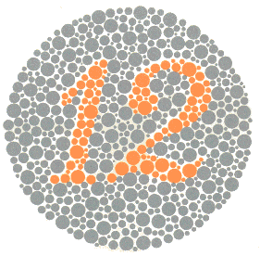 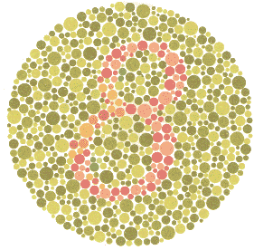

### Plate-1 Plate-2

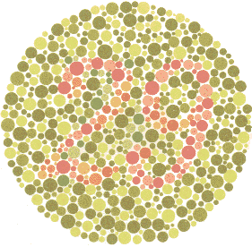 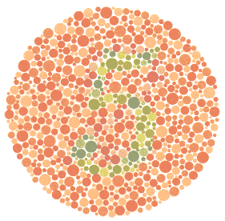

### Plate-3 Plate-4

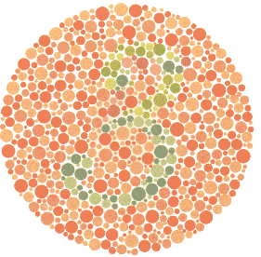 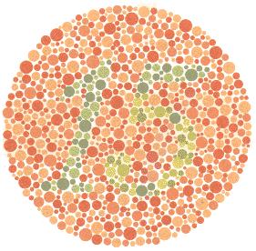

### Plate-5 Plate-6

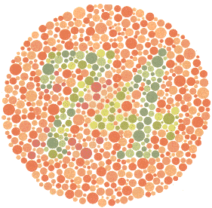 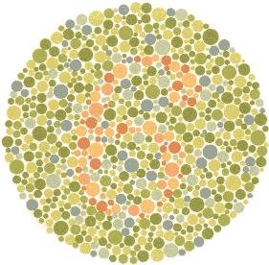

### Plate-7 Plate-8

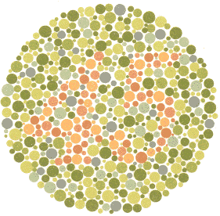 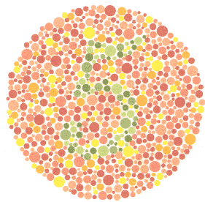

### Plate-9 Plate-10

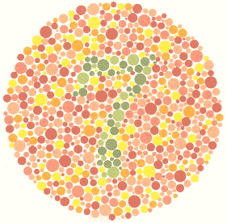 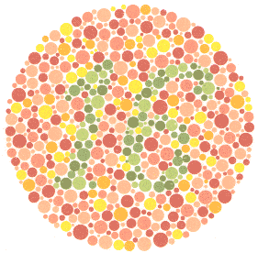

### Plate-11 Plate-12

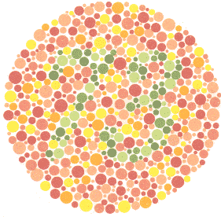 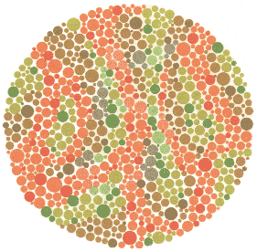

### Plate-13 Plate-14

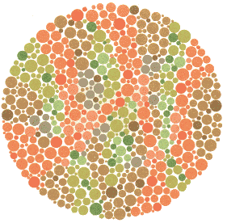 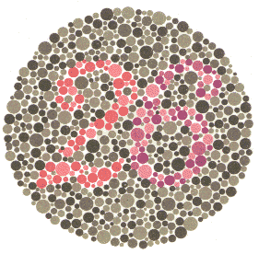

### Plate-15 Plate-16

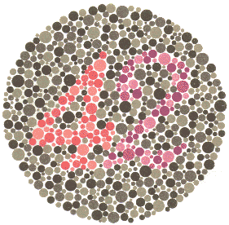 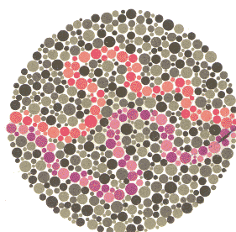

### Plate-17 Plate-18

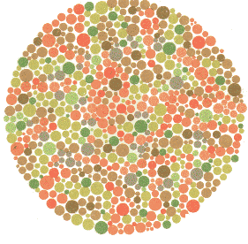 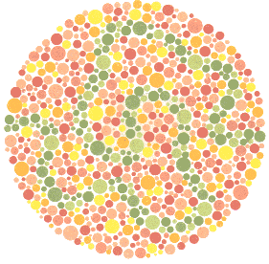

### Plate-19 Plate-20

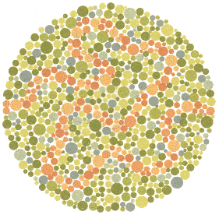 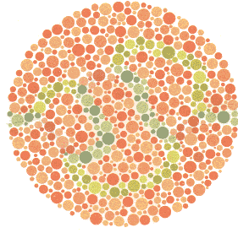

### Plate-21 Plate-22

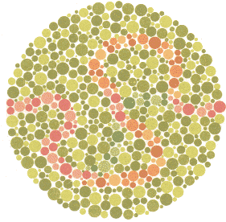 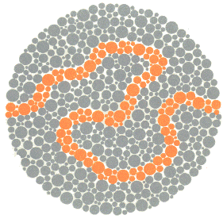

### Plate-23 Plate-24